|  |  |
| --- | --- |
| No. of Pages | **7** |
| No. of Questions | 7 |

**Department of Computer Science and Engineering**

**FINAL EXAMINATION SUMMER 2016**

**CSE490/EEE453: LAN Switching and WAN Technologies**

**Total Marks:75 Time Allowed: 2.5 Hours**

* Answer any **FIVE (5)** questions out of the given **SEVEN(7)** questions.
* Figure in bracket [] next to each question indicates marks for that question.

###### Question No. 1

1. What types of packets are used by EIGRP? For which packets does EIRGP use RTP and why? [4 marks]



**Figure No. 1**

1. Refer to figure no.1, the output is of which table of which router? This router is running which routing protocol? And what needs to be done so that the default route information is automatically sent via routing updates to other routers? [4 marks]
2. What is the purpose of hello interval and hold time in EIGRP? [3 marks]
3. A router running EIGRP finds 3 routes to the destination network 200.20.20.0.  
   Route X has FD 4123567 and RD 3011840

Route Y has FD 3278455 and RD 2045600

Route Z has FD 2465430 and RD 40680

Which route/s will become the successor and feasible successor/s? Explain your answer. [4 marks]

Question No. 2

**West#show interface serial 0**

**Serial0 is up, line protocol is down**

**Hardware is PowerQUICC Serial**

**Internet address is 198.19.249.252/30**

**MTU 1500 bytes, BW 128Kbit, DLY 20000 usec,**

**reliability 255/255, txload 1/255, rxload 1/255**

**Encapsulation PPP, loopback not set**

**<output omitted>**



**East#show interface serial 0**

**Serial0 is up, line protocol is down**

**Hardware is PowerQUICC Serial**

**Internet address is 198.19.249.254/30**

**MTU 1500 bytes, BW 128Kbit, DLY 20000 usec,**

**reliability 255/255, txload 1/255, rxload 1/255**

**Encapsulation HDLC, loopback not set**

**<output omitted>**

**Figure No. 2**

1. Refer to the figure no. 2, a system administrator is unable to ping the S0 interface of the West router from the East router. Find the problem/s and provide the solution/s. [4 marks]

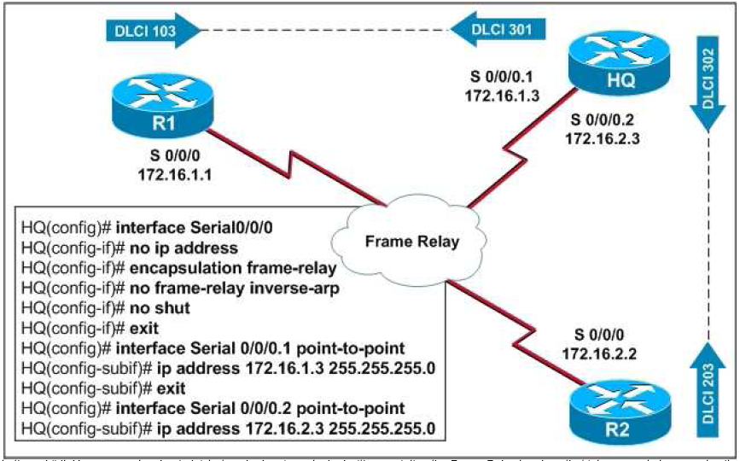

**Figure No. 3**

1. Refer to the figure no. 3 above. You are a network administrator who has been tasked with completing the Frame Relay topology that interconnects two remote sites. You have issued the following commands in HQ router but there is no frame-relay connectivity. What is wrong? [4 marks]

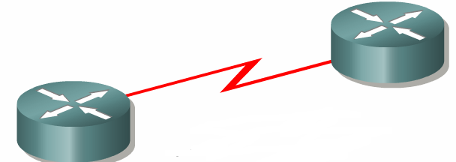

**Figure No. 4**

**Router A**

**Router B**

1. You are unable to ping from Router A’s serial interface to Router B’s serial interface shown in figure no.4, how can you find out whether it is a hardware problem or software problem? [3 marks]

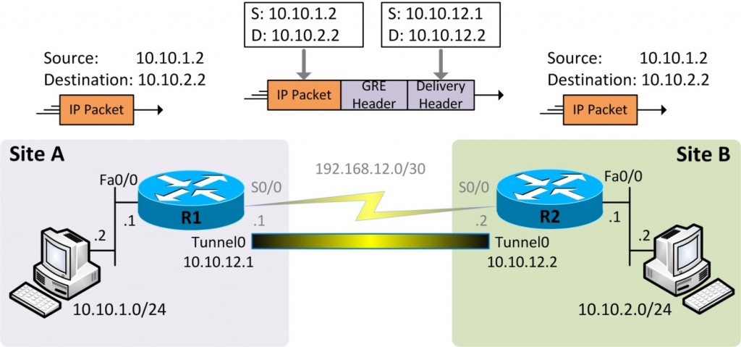

**Figure No. 5**

1. Referring to the commands shown in figure no. 5, Site A is unable to communicate with Site B. Find the problem/s and provide the solution/s. [4 marks]

## Question No. 3

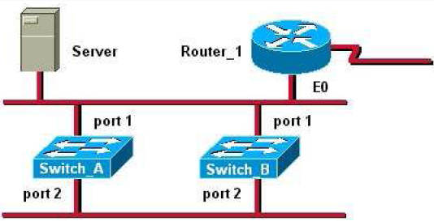

**Figure No. 6**

1. Refer to the figure no. 6, above. the Server sends a broadcast frame to the PC connected to Switch B at port 2 and then a PC connected with Switch A and another connected with Switch B also sends broadcast frames. If STP is not enabled, what will happen to the network? [4 marks]
2. Refer to the switched network shown in figure no.7 below, after running STP, Switch 2 is chosen as the root bridge. Now Switch 1 has two same cost paths to the root. How does it decide to choose its root port? . [4 marks]

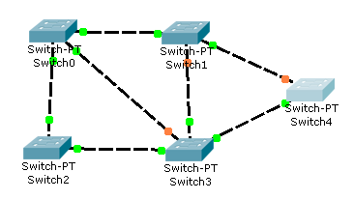

**Figure No. 7**

1. The figure no. 8 below shows the spanning tree output of Switch1. The interfaces have certain roles Desg, Root and Altn BLK, explain them. [4.5 marks]

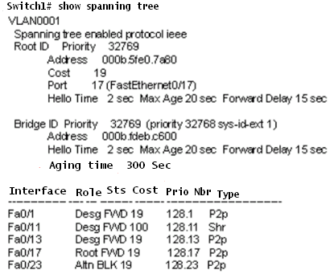

**Figure No. 8**

## 

## Question No. 4

1. Using figure no. 9, create a Named Extended Access List to allow host 192.167.10.10 to telnet into the FTP server located at 210.93.105.50, but prevent any other hosts from the 192.167.10.0/26 network to telnet into the FTP server. All other traffic is allowed. Do not forget to place the ACL. [6 marks]

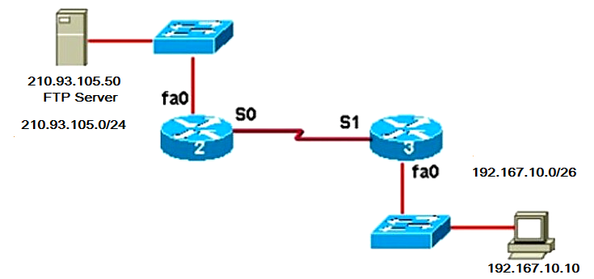

**Figure No. 9**

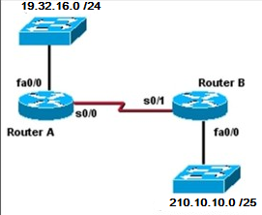

**Figure No. 10**

1. Refer to the figure no. 10 above; create a standard numbered ACL that will deny traffic from 210.10.10.0/25 network to the 19.32.16.0/24 network but will allow traffic from all other hosts. Where shall you place the ACL? [5 marks]
2. Refer to the figure no. 10 above; write a named standard ACL that will only allow the host 19.32.16.10 to telnet into the Router A. Do not forget to place the ACLs appropriately. [4 marks]

## Question No. 5

1. What is GRE used for? And why is GRE preferred in addition to IPSec? [4 marks]
2. What is the difference between Site-to-Site VPN and Remote Access VPN? [4 marks]
3. In Symmetric Key encryption why is AES preferred over DES or 3DES? [3 marks]
4. For IPSec Authentication what methods are used? Explain one briefly. [4 marks]

**Question No. 6**

1. What happens in the Link establishment phase of PPP? Who is responsible for it? [3 marks]
2. Explain the following commands [4 marks]
   1. compress stac
   2. ppp quality 70
3. During PAP authentication, why do we have use the following command “ppp pap sent-username HQ password HQPass” but not in CHAP? [4 marks]

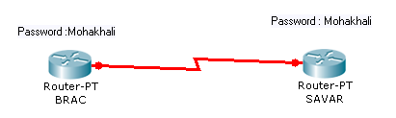

**Figure No. 11**

1. What happens after BRAC router sends a challenge packet to SAVAR router to start CHAP authentication, in figure no. 11? [4 marks]

## Question No. 7

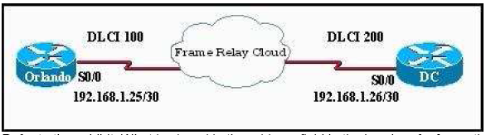

**Figure No. 12**

1. What kind of virtual circuit does DLCI 100 represent shown in figure no. 12? If DLCI 100 were to be numbered as DLCI 203, where would the network administrator have to make changes to ensure the virtual circuit between Orlando and DC router? [4 marks]





**Figure No. 13**

1. Using both outputs shown in figure no. 13, draw the topology. What does the word “dynamic” refer to? [5 marks]

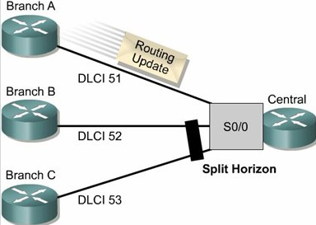

**Figure No. 14**

1. Refer to the figure no. 14 above. Router at Branch A sends a routing update to Central Router. The Central Router will not forward this update to Branch B and C, why? [3 marks]
2. What two main functions does the Local Management Interface perform in Frame Relay networks provide? [3 marks]

##### THE END